CR043

Ginger Source Name

**Contents**

1 Introduction 3

2 High Level Design 4

2.1.1 Ginger Dispute Source 4

3 Impact 5

3.1 Delivery Schedule 5

3.2 Resource 5

3.3 Infrastructure 5

3.4 Licensing 5

3.5 Service Costs 5

**Amendment History**

|  |  |  |  |
| --- | --- | --- | --- |
| **Revision** | **Date Issued** | **Author** | **Reason for Change / Description** |
| V1.0 | 22/03/2019 | Kevin Wing | Initial version |
|  |  |  |  |
|  |  |  |  |
|  |  |  |  |
|  |  |  |  |

# Introduction

There is a requirement to display the Source Name on the Dispute Case when we receive a dispute from Ginger. Currently we just display “Reseller” within the Dispute Case Home form.

It is important to note that we only receive the Dispute Code as part of the dispute, and the Source Name is looked up via a reference table held in our stash repository. Once the Optimus project is LIVE, should a new Dispute Source be sent as part of a Dispute, it will not be found unless our stash repository is also updated.

# High Level Design

### Ginger Dispute Source

We need to introduce an additional look up when receiving a Dispute from Ginger. Instead of showing “Reseller” as the source on the Dispute Case Home form, we need to show the actual Source name based on the Source Code we receive.

To achieve this, we can reference the stash type “Sources” and look up the Source Name. The result of the look up will populate the “SourceName” attribute within the “DisputeCase” stash type:

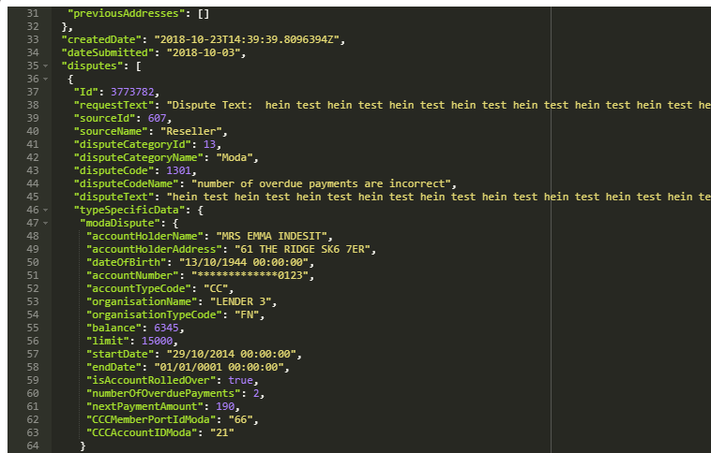

If we are unable to locate the Source Name from the reference table, it will default the behaviour currently in place.

# Impact

## Delivery Schedule

This is not a major change and could potentially be delivered in readiness for Phase 1 go-live

## Resource

|  |  |
| --- | --- |
| Description of work | Effort (days) |
| Build – Connect API | 1 |
| **Total Effort** | **1** |

## Infrastructure

There are no impacts on the proposed solution architecture because of this change.

## Licensing

There are no licensing implications related to this change.

## Service Costs

There are no service costs related to this change.